Modell: | Motor: | Karosszéria: | Kép: | Név: | Piac | Évjárat:
KE10 | K | 2dr sedan | 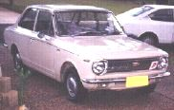 |  | Aust, Euro | 1968
KE10 | K | 4dr sedan | 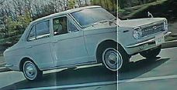 |  | Aust, Euro | 1968
KE11 | 3K | 2dr sedan | 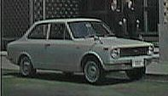 |  | Aust, Euro | 1970
KE15 | K, K-B | 2dr coupe | 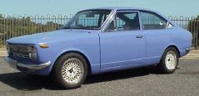 | "Sprinter" | Aust, Euro | 1969
KE16 | K | 2dr wagon | 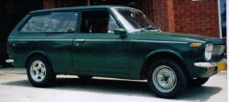 |  | Aust, Euro
KE17 | 3K-B | 2dr coupe | 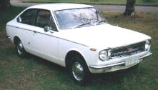 | "Sprinter" | Aust, Euro
KE18 | 3K | 2dr wagon |  |  | Aust, Euro
KE20 | 3K | 2dr/4dr sedan | 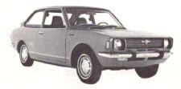 | (peanut) | Aust.
TE21 | 2T | 2dr/4dr sedan | 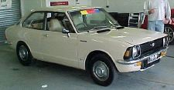 | (peanut) | USA
KE25 | 3K | 2dr coupe | 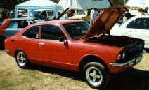 | (Mango) | Aust. | 1971-74
KE26 | 3K | 2dr wagon | 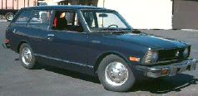 |  | Aust, Euro | 1971
TE27 | 2T, 2T-B, 2TG | 2dr coupe | 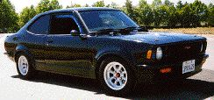 | "Levin", "SR-5" (Mango) | USA, Japan
TE27 | 2T, 2T-B, 2TG | 2dr coupe | 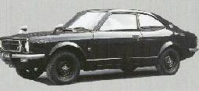 | "Sprinter Trueno" | Japan | 1971-74
KE28 | 3K | 2dr wagon |  |  | Aust, Euro
TE28 | 2T | 2dr wagon | 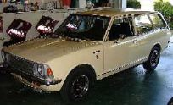 |  | USA, Japan
KE30 | 3K | 4dr sedan | 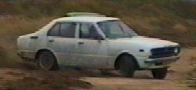 |  | Aust, Euro | 1974-77
KE30 | 3K | 2dr sedan | 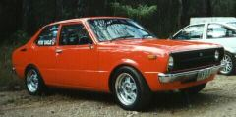 |  | Aust, Euro, USA | 1974-78
TE31 | 2T, 2T-B | 2dr/4dr sedan | 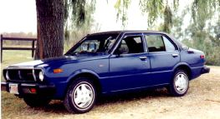 |  | USA | 1975-1979
KE35 | 3K or 3K-B | 2dr coupe hardtop | 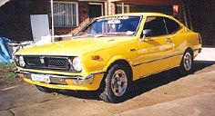 |  | Aust | 1974-78
TE35 | T-U, 2T | 2dr coupe hardtop | 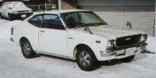 |  | Japan | 1975-76
KE36 | 3K | 2dr/4dr wagon | 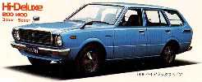 |  | all | 1974-78
TE36 | T | 2dr/4dr wagon
KE37 | 3K |  |  |  | ?
TE37 | 2T, 2T-B, 2T-G | 2dr coupe hardtop | 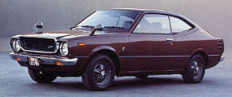 | "Levin", "SR-5" | Japan, USA | 1975-78
KE38 | 4K | 2dr/4dr wagon | 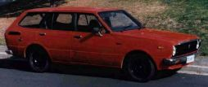 |  | Aust, Euro | 1978-81
TE38 | 2T | 2dr/4dr wagon |  |  | USA | 1978-80
TE39 |  |  |  |  | ?
KE40 | 4K, 3K-H, 3K-B |  |  | Sprinter
TE41 | 2T, 2T-B |  |  | Sprinter | Japan
KE45 | 4K, 3K-H |  |  | Sprinter
TE47 | 2T, 2T-B, 2TG | 2dr coupe | 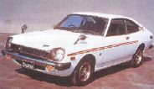 | Sprinter "Trueno" | Japan | 1974-78
KE50 | 3K | 2dr liftback | 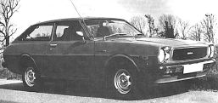 |  | Aust, Euro | 1976-79
TE51 | 2T | 2dr liftback | 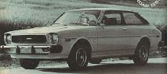 |  | USA | 1977-78
TE51 | 2TGEU | 2dr coupe | 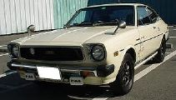 | "Levin GT" | Japan | 1976-78
TE51 | 2TGEU | 2dr liftback | 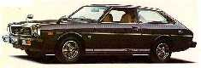 | "Levin GT" | Japan | 1976-78
TE52 | 2T | 2dr hardtop | 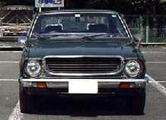 |  | Japan
KE55S | 4K, 4K-B | 2dr coupe hardtop |  |  | Aust | 1978-81
KE55E | 4K, 4K-B | 2 & 4dr sedan | 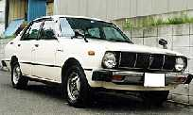 |  | Aust, Japan | 1978-81
TE55 | 2TGEU | 2dr coupe | 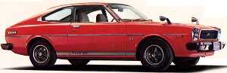 | "Levin GT" | Japan | 1978-79
TE55 | 2TGEU | 2dr liftback |  | "Levin GT" | Japan | 1978-79
TE56 | 2T
KE60 | 3K |  |  | Sprinter
TE61 | 2TGEU | 2dr coupe | 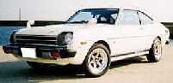 | "Sprinter Trueno" | Japan | 1977
TE62 | 2T, 12T | 2dr coupe | 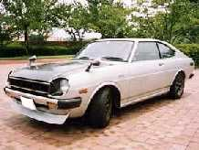 | Sprinter | Japan
KE65 | 4K-U |  |  |  | ?
TE65 | 2TGEU | 2dr coupe |  | "Sprinter Trueno" | Japan | 1978
TE66 | 2T | 4dr | 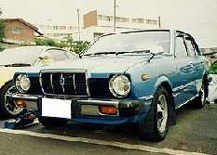 | Daihatus Charmant | Japan
KE70 | 4K | sedan/ wagon | 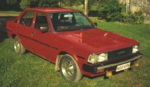 |  | Aust, Euro | 1981
KE70 | 4K | sedan/ wagon |  | Sprinter |  | 1981
KE70 | 4K | wagon | 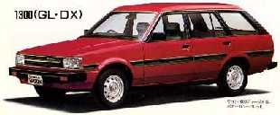 |  |  | 1981
KE70 | 4K | van | 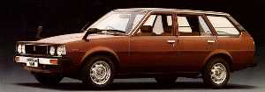 |  |  | 1981
TE70 | 3TC | wagon | 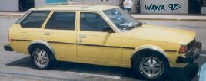 |  | USA
TE70 | 3TC | 2dr sedan |  |  | USA
TE70 | 2T,3TE, 12T, 13T, 2TGEU | 4dr sedan | 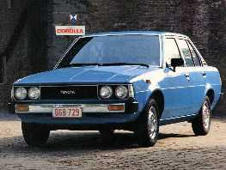 | "GT" | USA, Japan
CE70 | 1C diesel | sedan/ wagon |  |  | Euro
AE70 | 3A-U | 2dr coupe | 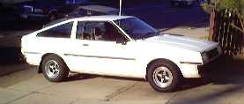 | "Sprinter" | ? | 1981
AE71 | 4AC | sedan/ wagon |  | spirit | Australia | 1983
TE71 | 2TGEU | 2dr coupe | 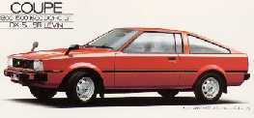 | "Levin" | Japan | 1979
TE71 | 2TGEU | 2dr coupe | 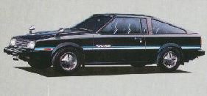 | "Sprinter Trueno GTApex" | Japan | 1979
TE71 | 2T,3T, 2TGEU | 2dr hardtop |  | "Levin" | Japan
TE71 | 2T,3T, 2TGEU | 2dr hardtop |  | "Trueno" | Japan
KE72 | 4K |  |  |  | ?
TE72 | 3TC | wagon
TE72 | 3TC | 4dr |  |  |  | 1982
TE72 | 3TC, 2TGEU | 2dr liftback | 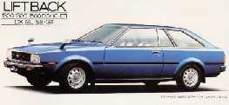 | "T-18", "SR-5", "GT" | Aust, USA, Japan | 1979
TE72 | 2TGEU | 2dr hardtop | 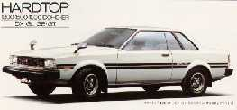 | "Levin" | Japan | 1979
AE72 | 4A-C | 2dr liftback | 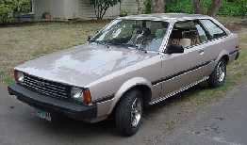 | "SR-5" | USA | 1982-84
AE72 | 4A-C | 2dr hardtop |  | "SR-5" | Puerto Rico | 1982-84
KE73E | 4K |  |  |  | ?
TE73 | 2T,3TE, 12T, 13T | wagon | 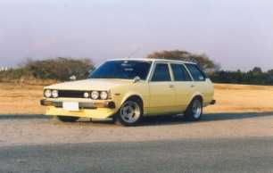
KE74E | 5K
TE74 | 2T,3TE, 12T, 13T |  |  |  | Japan
TE75 | 3T |  |  |  | ?
AE85 | 3A-U | liftback | 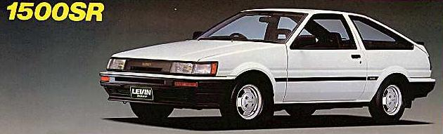 | "Levin" | Japan | 1983-86
AE85 | 3A-U | coupe | 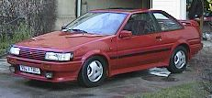 | "Levin" | Japan | 1983-86
AE86 | 4A-GEU | 2dr coupe | 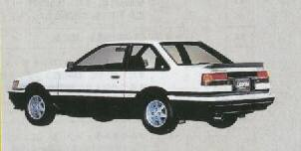 | "Levin" | Japan, USA
AE86 | 4A-GEU | 2dr liftback | 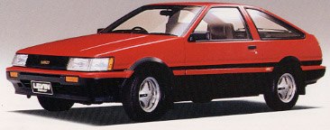 | "Levin", "Levin GT-Apex", GTV Apex" | Japan | 1983-86
AE86 | 4A-GEU | 2dr coupe | 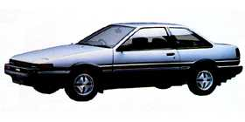 | "Sprinter Trueno" | Japan | 1983-86
AE86 | 4A-GEU | 2dr liftback | 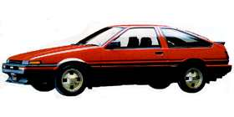 | "Sprinter Trueno", GT Apex | Japan | 1983-86
AE86 | 4A-C | 2dr liftback | 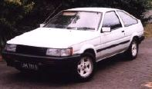 | "Sprinter" | Australia | 1983-85
AE86 | 4A-GEC | 2dr liftback | 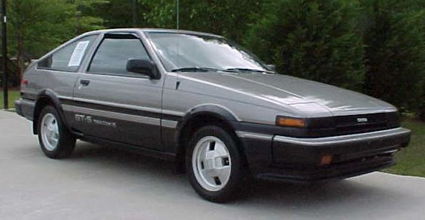 | "GT-S" | USA/ Canada | 1983-87
AE86 | 4A-GEC | 2dr liftback/coupe |  | "GTS" | USA/ Canada | 1983-87

